|  |
| --- |
| Report |

Assignment 1

*2DV516*

|  |
| --- |
| *Author : Chelsea Alambuya*  *Email ca223sf*  *Semester: Spring 2024* |

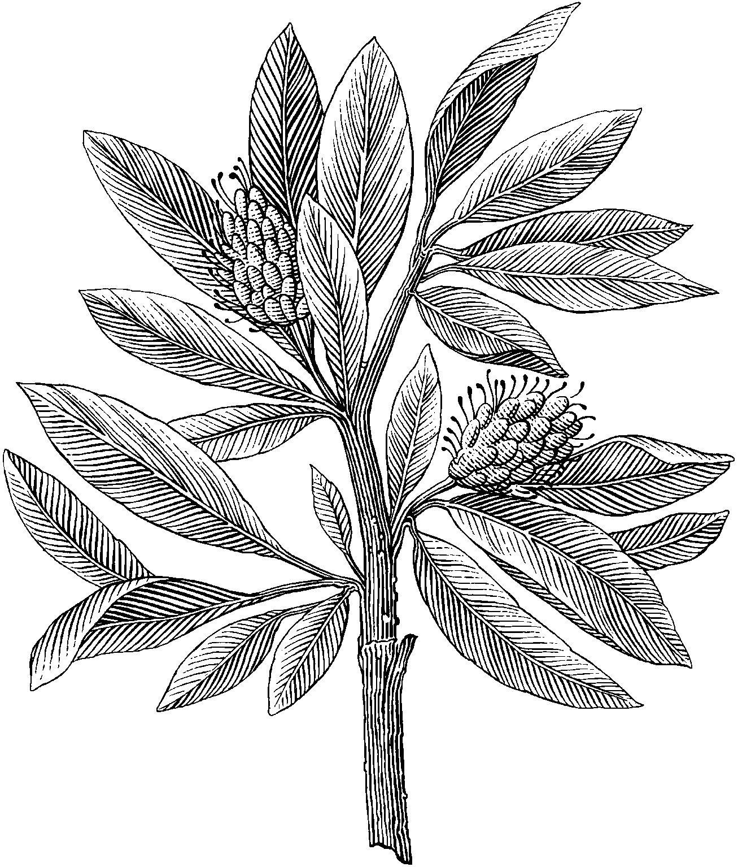

Contents

1 Problem 1 1

1.1 Discussion 2

2 Problem 2 4

2.1 Discussion 6

3 Problem 3 7

3.1 Discussion 8

4 Problem 4 9

4.1 Discussion 10

# Problem 1

## Images

*Figure 1.1: Read and write requests shorter than 512 bytes.*

*Figure 1.2: Tftpd64 215Bytes file read request.*

*Figure1.3: Tftpd64 215Bytes file write request.*

## Discussion

# Problem 2

## Images

|  |  |
| --- | --- |
| *Figure 2.1: Terminal output for write request with files of 600Bytes and 3000Bytes.* | *Figure 2.2: Tftpd64 3000Bytes file write request.* |
| *Figure 2.3: Tftpd64 600Bytes file write request.* |

|  |  |
| --- | --- |
| *Figure 2.4: Terminal output for read request with files of 600Bytes and 3000Bytes.* | *Figure 2.5: Tftpd64 600Bytes file read request.* |
| *Figure 2.6: Tftpd64 3000Bytes file read request.* |

## Discussion

# Problem 3

## Images

*Figure 3.1: Sever side capture.*

*Figure 3.2: Client side capture.*

## Discussion

# Problem 4

## Images

*Figure 4.1: not defined.*

*Figure 4.2: file not found.*

*Figure 4.3: Access violation.*

*Figure 4.4: file already exists.*

## Discussion

# References